What is in this note?
Link | Description
About us | Brief Intro to C2L and PlanetLab
L2L main objectives | Roles and Responsibilities
Visas & Passports | Very Important!!
Overview & Climate | Nepal and climate
Nepal Dos and Don'ts | Short list of what to expect in Nepal
Packing Guide | Please read carefully
Places we will visit | Mapping the Plan
Emergency contact info | Trip leaders (WhatsApp, WeChat)
Resources | Questions?  brian.mcadoo@duke.edu  binbin.li@duke.edu  Saniyabhusal001@gmail.com  rajbhandari.anek@gmail.com  ojaswee.karki.8.c@gmail.com  rrinchentamang@gmail.com

About the Program
The 2026 Himalayan Planetary Health Transect is an immersive, field-based learning journey designed for undergraduate students from diverse academic disciplines: environment, engineering, humanities, and health sciences. Over the course of the program, we will traverse Nepal's extraordinary ecological gradient, from the subtropical lowlands of Chitwan to the high-altitude desert of Lo Manthang in Upper Mustang, one of the most dramatic climate transitions on Earth.
Rather than studying planetary health from within a classroom, we will encounter it directly: in shifting landscapes, in the communities that depend on them, and in the stories of people living at the intersection of climate change, biodiversity loss, and health. The transect is structured around four core themes:
- Climate — Understanding how temperature, precipitation, and seasonal patterns are changing across Nepal's ecological zones.
- Health — Exploring how environmental disruption shapes community well-being, disease burden, and psychosocial resilience.
- Biodiversity — Observing the range of ecosystems, flora, and fauna across the transect, and the pressures they face.
- Restoration — Examining efforts to regenerate degraded ecosystems and the communities driving them.

PlanetLab at Duke University, USA, is led by Professor Brian McAdoo and brings together science, storytelling, and local partnerships to address climate risk and advance planetary health in vulnerable regions like the Himalayas. By understanding the intersection of Earth systems with exposed communities, PlanetLab is working to reduce the risks associated with global environmental changes.

This guide will help you with key things to consider before your travel—what to pack, how to prepare, and what to expect in Nepal’s diverse environments.

Transect Flow: Chitwan → Pokhara → Marpha → Kagbeni → Ghami → Lo Manthang

C2L Objectives, Roles and Deliverables
Main Objectives:

- How is climate change manifesting in the Terai, Middle Hills, Alpine and Tibetan Plateau regions of Nepal?
- What are the major land use/land cover changes in these regions? How do they differ?
- Are there any other societal factors that are having direct or indirect impacts on the environment (economy, migration, religion/world view?)
- Does the array of health challenges people are facing change along the transect?
- Do impacted people see links between their health and environmental change?
- How can we collect reproducible data to support our observations?

Student Roles:

- Be curious.
- Ask the local professionals and residents, your classmates and professors about their perspectives on these climate and health changes impacts.
- Take photos. Collect stories. Every night we will review our visual and narrative data and record notes and reflections in your field notebooks. Photojournalist Tom White will be working with you to keyword and tag your images and notes with Planetary Health terminology so we can map the stories to the frameworks.
- Think about what data we can collect for long-term empirical study.

Deliverables:

- Storymap of our Climate and Health transect across Nepal;
- Bound volume of photos and stories of climate and health from the Terai, Middle Hills, Alpine and Tibetan Plateau regions.

Visas & Passports (For Duke & DKU students)
✅ Be sure to register with the Duke Travel Registry! This is required for coverage under our comprehensive emergency travel assistance program, International SOS. This is not optional. We will help you complete your registration if needed.
✅ Travel visas to Nepal are on-arrival. You will need to bring $50 in cash (USD).
✅ Please pre-apply for the visa online here. Saves time. Maybe… (EWOP**)
✅ Also make sure you visit this Link to learn more about Visa requirements for Nepal. Contact us if you need more details.
✅ Always keep your passport on you and make a copy which you keep at the hotel.
✅ Important! Please bring 10 passport photos with you and keep with your passport. These will be needed for the variety of trekking permits we will require.

Nepal Overview & Climate
Nepal is a beautiful country nestled in the foothills of the Himalayas. Bordered by China and India, it boasts a diverse topography, ranging from fertile plains in the south to some of the world’s highest peaks in the north. What’s truly fascinating is that the difference in altitude between the lowest point and the summit of Mount Everest is a staggering 8,700 m vertical, yet these extremes are separated by just 180 km! This dramatic change in elevation within such a short distance highlights the incredible diversity of Nepal’s landscape. The nation also has a rich cultural heritage, shaped by its numerous ethnic groups, languages, and traditions, with Hinduism and Buddhism being the predominant religions. You can dive in more here on the documents that we have prepared for you: Nepal 101 and Nepal Government system
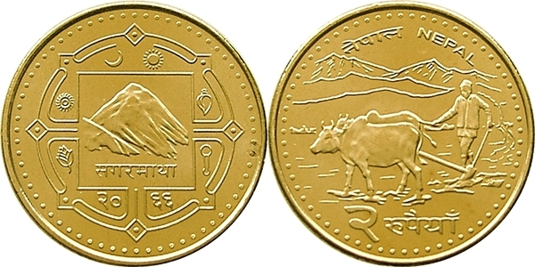
Two Rupees Coin featuring Mount Everest and
a farmer with the Himalayas in the backdrop.

Climate - what to expect:
We will be traveling during the pre-monsoon season along a transect that follows the Kali Gandaki River—from the lowland plains at 100 m above sea level (where mid-May temperatures can exceed 40°C/100°F) to Lo Manthang at 3800 m above sea level on the Tibetan Plateau (with daytime highs around 10°C / 50°F and nighttime lows down to -2°C / 27°F). You can learn more about climate conditions through links in the Places We Will Visit section.

Careful packing is essential!

Nepal do’s and don’ts
Cultural Etiquette:
✅ Greet people with “Namaste” 😀
✅ Do dress modestly—cover shoulders and knees, especially in rural or religious areas.
✅ Do remove shoes before entering homes, temples, and monasteries.
❌ Don’t show public displays of affection.

Health, Hygiene and Safety:
✅ Do drink only bottled, filtered, or boiled water.
✅ Do brush your teeth with clean water only (not tap water).
✅ Do carry and take Imodium—stomach issues are common. We will provide hydration salts as needed.
✅ Do bring a personal supply of any required medication.
✅ Do apply mosquito repellent with DEET and wear long sleeves/ pants when we visit the Terai area. There is a high risk of malaria in this region.
✅ We will be travelling in altitudes between 150 and 4,200 meters above sea level and will do our utmost to gradually acclimatize. However it is your responsibility to be attentive to symptoms of altitude sickness and let our guides know if you are not well.
✅ Do rest and hydrate as we ascend.
✅ If you know you suffer from altitude sickness, consider using Diamox.
❌ Don’t push through severe symptoms—tell faculty immediately.
❌ Do not observe or join any political rallies. Our Nepali hosts will provide information on any planned rallies and how to avoid them.
❌ Don’t open your mouth in the shower.🙄

Money & Payments:
✅ Do exchange some USD to NPR at the airport or in Kathmandu.
✅ Do carry small bills—many places won’t have change.
❌ Don’t rely solely on credit/debit cards. ATMs can be unreliable, especially outside major cities.

Electricity & Devices:
✅ Do bring a universal adapter - Nepal uses Type C and Type D electrical plugs- here for more information
✅ Do carry a power bank, it will be helpful.

Internet access
✅Most of the hotels and mountain lodges have free wifi, although this cannot be guaranteed.
✅Check with your phone provider for roaming service, some do offer this in Nepal. If not, you have the option to get a SIM at the airport.
✅ You also have the option of purchasing a 4G internet package at the airport.
❌ Do not expect to be connected 24/7 and enjoy the liberation of not always having internet access.

Respect for Local Life
✅ Do ask permission before taking photos of people or religious sites.
✅ Do wear shoes that are easy to get on and off as it is customary to remove shoes before entering homes and some temples.
✅ Do be patient and flexible—timing and logistics can change.
✅ Do respect local customs, even if unfamiliar.
✅ Do respect quiet hours and meal times.

Food and Eating
✅ Do wash your hands before and after eating—you are invited to eat with your hands when appropriate!
✅ Do be cautious with street food unless you’re sure it’s freshly made and hygienic. Please ask our local colleagues if they think it is safe.
✅ Do inform organizers in advance if you have dietary restrictions— vegetarian options are widely available.

Travel insurance
All Duke students that have registered with the Duke Travel Registry (https://travel.duke.edu/registry/) will be covered by International SOS (https://globaled.duke.edu/isos/). This will provide everyone with access to emergency medical care, logistics support and security reports, and will evacuate us if needed. Please print out the ISOS Card (https://travel.duke.edu/sites/default/files/ISOS_Card.pdf) and keep with your passport.

What’s included and not included
Included:
✅ Food (3 meals per day, pre-set lunch menus) and lodging (shared same sex rooms).
✅ Transportation: international and domestic airfare and all local ground transportation as described in the itinerary.
✅ Admission fees to all temples and museums, trekking permits permits and the Tatopani hot springs!
✅ Emergency transportation back to Kathmandu if needed.
✅ A life-changing learning experience!

Not included:
❌ Snacks and drinks other than water.
❌ Laundry costs (around 2-3 USD/ load at laundry services in Kathmandu and Pokhara)
❌ Daily hot showers (now and then we may actually get a hot shower, but you may have to pay a small fee).
❌ Abusive alcohol consumption and any drug consumption may require trip leaders to expel you (let’s avoid this situation, please).
👍

Packing guide
Please pack as light as possible. Leave the “want to haves” behind, focus on the “need to haves”. We will have limited space on the buses, so only one med-size (max 40-50 liters) trekking backpack and one small daypack (max 30 L) per traveler will be allowed (see below section for more details).

Clothing

Base Layers (for moisture-wicking and comfort)
- Moisture-wicking T-shirts (quick-drying)
- Long-sleeve shirts (lightweight and breathable for sun protection)
- Moisture-wicking underwear
- Moisture-wicking, quick dry socks

Mid Layers (for warmth in cooler temperatures)
- Fleece or lightweight down jacket (packable and warm)
- Long-sleeve thermals (wool or synthetic for layering)
- Warm hoodie or pullover (for more casual wear in the evenings)

Outer Layers (for weather protection)
- Waterproof jacket
- Durable, quick-drying trousers
- Shorts

Hats & Gloves
- Wide-brimmed sun hat, cap (essential)
- Warm beanie
- Light gloves
- Thermal gloves

Footwear
- Comfortable hiking boots/trail shoes (well-broken-in, optional waterproof)
- Lightweight sandals or flip-flops
- Light trainers/running shoes/sneakers

Accessories
- Sunglasses
- Bandana or buff (dust protection, sunshade)
- Compact travel umbrella (optional but useful)
- Quick-drying towel
- Swim Shorts (quick drying t-shirts for women)
- Trekking poles (optional)
- Carabiners for clipping, carrying, hanging items etc

Fieldwork & Trekking Equipment

Backpack & Daypack
- 1 medium-sized backpack (40–50 liters maximum)
- 1 small daypack (for shorter day treks)
- Poncho & backpack rain cover (can be purchased in Kathmandu)
- Bag liners and packing cubes (to keep things organised and separate clean items)
- Dirty/Wet clothes & shoes bag (heavy duty plastic bags can serve)

Sleeping Gear
- Sleeping bag liner
- lightweight sleeping bag (Optional. We can also rent sleeping bags in Nepal)

Hydration
- Water bottle (e.g. Nalgene) and/or hydration reservoir (at least 2–3 liters of water capacity)
- Water purification tablets or a filtration system (Optional. We will provide drinking water)

Fieldwork Gear
- Field notebook
- Pens, pencils, refills
- Smartphone (with camera - if you have a flip phone, please bring a separate camera, ideally digital)
- Headlamp or flashlight + spare batteries
- Multi-tool or Swiss Army knife (optional)

Personal Care & Hygiene
- Mosquito repellent with DEET
- Biodegradable soap/shampoo (suitable for use in streams and rivers)
- Compressed towels/expandable wipes eg Portawipes (optional)
- Travel clothesline (optional)
- Toothbrush and toothpaste (small travel-sized)
- Sunscreen (SPF 30 or higher)
- Lip balm with SPF
- Personal hygiene wipes
- Hand sanitizer (essential, especially for hygiene in remote locations)
- Personal first aid kit (Optional. We will have kits, but if you want to have your own personal first aid items, pain relief, stomach settlers, band-aids, antiseptic, blister pads, painkillers, personal meds etc.)
- Sanitary products

Electronics & Power
- Camera or smartphone (for documenting observations and fieldwork)
- Portable power bank (for charging devices on the go)
- Adapters for charging (Nepal uses the Type C and Type D electrical plugs)
- Solar charger (Optional)

Miscellaneous
- Dry bags or zip-lock bags (Optional. For waterproofing valuables)
- Permits and ID (keep copies for emergency situations)
- Cash - USD and Nepali Rupees (especially for small purchases and remote areas)

Optional Items for Comfort
- Travel pillow (for long bus rides or nights in less comfortable accommodations. Packable/inflatable recommended)
- Earplugs and sleep mask
- Travel Mug
- Spork
- Yorkshire Tea 🙄

Route and Climate Overview
The transect moves north through progressively higher altitudes, drier air, and colder temperatures. Here is what participants can expect at each stop:

- 13-14 May: Kathmandu (1,400 m)— Kathmandu is the capital city of Nepal, located in a valley surrounded by the Himalayas. It is known for its ancient temples, vibrant markets, and rich blend of Hindu and Buddhist culture. The city serves as Nepal’s political, cultural, and economic center.

- 15-17 May: Chitwan (100-815 m) — Subtropical lowland. Hot and humid, especially in late spring and summer, with temperatures often exceeding 35°C. Home to dense sal forests, wetlands, and one of Asia's most important wildlife corridors.

- 18-20 May: Pokhara (822 - 827 m) — A mid-hill city at the foot of the Annapurna range. Warm and temperate, typically 20–28°C during the program. High rainfall due to its position as one of the wettest places in Nepal.

- 21-22 May: Marpha (2,670 m) — A historic apple-growing village in the Kali Gandaki valley. Noticeably cooler (10–18°C), with strong afternoon winds funneling through the gorge. Transitional zone between mid-hills and high mountain.

- 23 May: Jomsom (2,720 m) — The administrative hub of Mustang district. Arid and windswept, with gusty afternoons common. Temperatures range 8–18°C. Gateway to Upper Mustang.

- 23 May: Kagbeni (2,800 m) — A medieval walled village at the confluence of the Kali Gandaki and Jhong rivers. Entry point to restricted Upper Mustang. Dry, rugged terrain; 6–15°C.

- 24 May: Ghami (3,520 m) — A high-altitude settlement in the Upper Mustang plateau. Stark, wind-carved landscape. Temperatures drop to 2–10°C; cold nights are common.

- 25-27 May: Lo Manthang (3,840 m) — The ancient walled capital of the Kingdom of Lo. The highest and most remote point of the transect. Temperatures may fall below 0°C at night. Thin air, strong winds, intense sun, and extraordinary silence.

Note: Weather in the Himalayas is unpredictable. Conditions can change rapidly at altitude. Always carry layers regardless of the forecast.

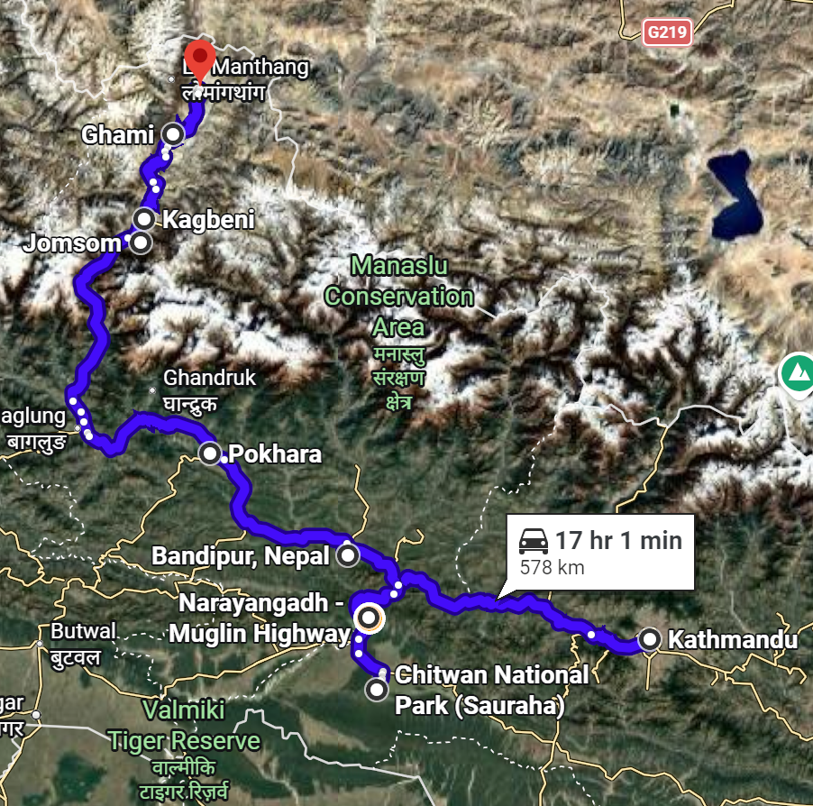
Figure: Explore more here!

Learning Materials
To make the most of our time in the field, we ask you to do a bit of reading and watching beforehand.

Before the Transect

Read At Least Two Papers or Reports
We have put together a Nepal 101 doc to familiarize you with Nepal before you arrive. Please read at least two papers from the curated list, this is mandatory for international students visiting Nepal for the first time. We have also compiled a selection of academic papers and reports connected to the regions we will be visiting, covering themes of climate change, biodiversity, community health, and ecological restoration. These can be read before, during, or after the transect. Don't feel overwhelmed by the number of articles, think of them as a resource to dip into when curious or when something in the field sparks a question. 😊

Watch At Least One Documentary
The Nepal 101 doc also includes a curated list of documentaries to help orient you to Nepal. Please watch at least one before you arrive. We also have a separate list of documentaries tied to the specific regions and themes we'll be moving through along the transect.
If time allows, we'd love for you to organize a watch party or screening with friends — whether or not they're joining the transect. 🙌

During the Transect

Transect Prospectus
All participants will receive a Transect Prospectus, a companion document covering the major areas along the transect. It provides contextual background on the landscapes, communities, and themes you will encounter in the field, and is meant to be referenced throughout the program.

Route Briefing
We will be spending a lot of time on the road, so settle in 🚗. The landscapes and views along the way are, trust us, genuinely stunning. As we move through different geographical and climatic zones, there is a lot to observe and absorb. We have prepared a Route Briefing [link] for each stretch of the journey; not spoilers, but a set of pointers and things to watch for: changes in vegetation, temperature shifts, land use patterns, and more. Think of it as a thoughtful checklist to keep your eyes and mind open while the scenery unfolds.

Emergency contact info
We find that WhatsApp and WeChat are the best ways to communicate internationally.
Trip Leaders
Prof Brian McAdoo | +1 845-249-9561 🇺🇸 | brian.mcadoo@duke.edu
Prof Binbin Li | +86 138 1025 1904 🇨🇳 | binbin.li@duke.edu
Tom White | +65 9772-3330 🇸🇬 | tomwhitephotography@gmail.com
Purna Rajbhandari | +977 9813078388 🇳🇵 | rajbhandari.purna@gmail.com
Sanjay Devkota | +977 9823343682 🇳🇵 | devkotasanjaya@gmail.com
Shachi Truong | +977 9851215566 🇳🇵 | karen.sudmeier@gmail.com
Saniya Bhusal (TA) | +977 9840899234 🇳🇵 | Saniyabhusal001@gmail.com
Anek Rajbhandari (TA) | +977 9840386622 🇳🇵 | rajbhandari.anek@gmail.com
Ojaswee Karki (TA) | +977 9861598563 🇳🇵 | ojaswee.karki.8.c@gmail.com
Rinchen Tamang (TA) | +977 9812378374 🇳🇵 | rrinchentamang@gmail.com
Duke University Contacts
Duke-DKU Office | +1 919-681-2064 🇺🇸 | irina.adams@duke.edu
Duke Nicholas School of the Environment (Sherri Nevius) | +1 919-214-0303 🇺🇸 | sherri.nevius@duke.edu
Duke Office of Global Health and Safety (Anna Hayes) | +1 919-452-9546 🇺🇸 | anna.hayes@duke.edu
Nepal In Country Contacts
Karma Flights (Renuka Karki) | +977 9846219859 🇳🇵 | renuka@karmaflights.org
US Embassy Kathmandu | +977 1-423-4000 🇳🇵 | https://np.usembassy.gov/
Chinese Embassy Kathmandy | +977-1-4519389 🇳🇵 | https://np.china-embassy.gov.cn/

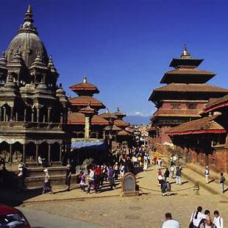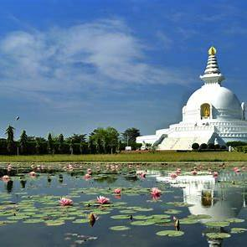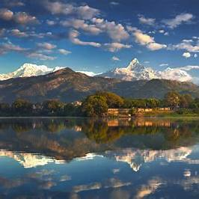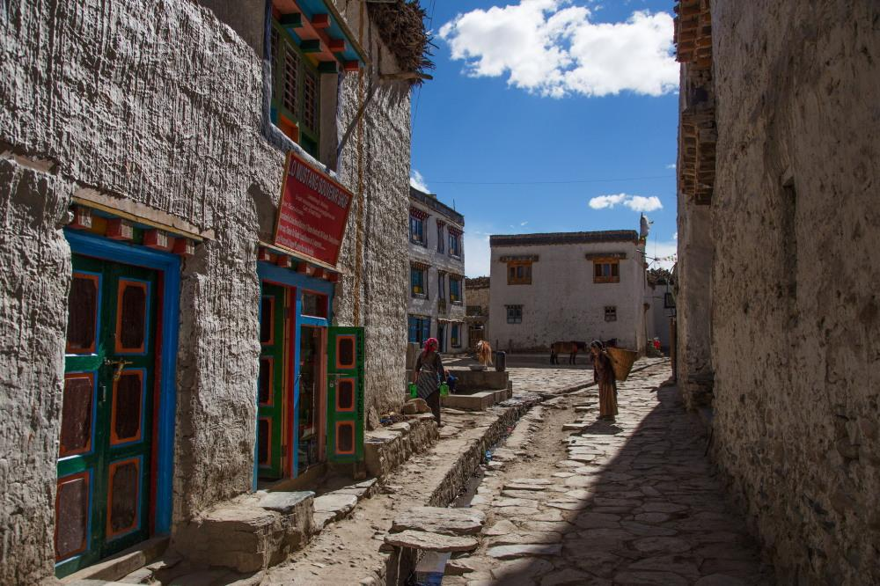
We look forward to walking this transect with you.
Come ready to observe, question, and connect.

